APPENDIX B: USE OF AI TOOL(S) IN PROJECT WORK

Each team member should indicate either A or B.
- I affirm that my contribution(s) to the lab work is my own, produced without help from any AI tool(s)
- I affirm that my contribution(s) to the lab work has been produced with the help from AI tool(s)

Full Name | Date | A or B
Khanak Jindal | 10/11/2024 | B
Iman Dzafir | 10/11/2024 | A
Li Tianze | 10/11/2024 | B
Crystal Nathasha | 10/11/2024 | A

By including this information in your jupyter notebook, you declare that the above affirmation made is true and that you have read and understood NTU’s policy on the use of AI tools.

If any team member answered B, the team member(s) must indicate and replicate the table below for every instance AI tool(s) is used.
Name of AI tool | Chatgpt
Input prompt | whats wrong:with open(file_path, mode='r', encoding='utf-8-sig')
Date generated | The syntax you've provided is mostly correct, but there is a small issue with how the file is being opened in the code.  Here is a breakdown of the potential issue:  - utf-8-sig is a valid encoding, but it should be used when handling files with a Byte Order Mark (BOM) for UTF-8 encoding. If your file is encoded with a BOM, utf-8-sig is appropriate to use. Otherwise, just use 'utf-8' if there is no BOM.  - The issue might be that the file path or mode is not correctly passed to the open() function.
Output generated | The syntax you've provided is mostly correct, but there is a small issue with how the file is being opened in the code.  Here is a breakdown of the potential issue:  - utf-8-sig is a valid encoding, but it should be used when handling files with a Byte Order Mark (BOM) for UTF-8 encoding. If your file is encoded with a BOM, utf-8-sig is appropriate to use. Otherwise, just use 'utf-8' if there is no BOM.  - The issue might be that the file path or mode is not correctly passed to the open() function.
Output screenshot | 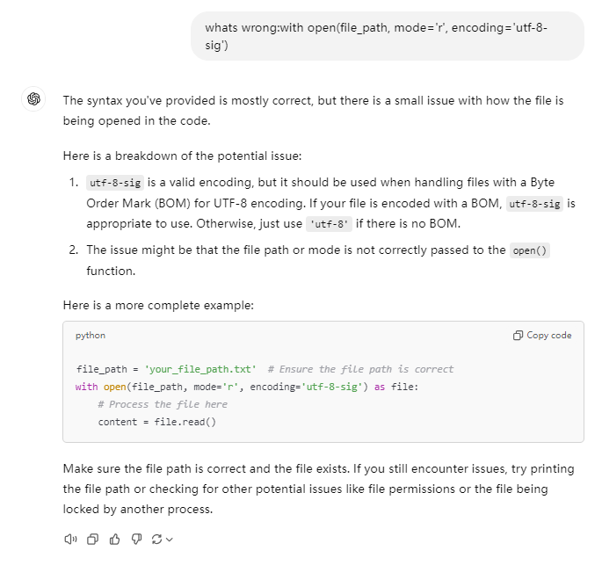
Impact on  submission | Help me debugging
Input prompt | check grammer:This table shows the average CGPA of each tutorial group (the second column) and the average CGPA of the 10 teams in each tutorial group (the third to twelfth columns).
Date generated | The sentence is grammatically correct. However, here’s a refined version for improved flow:  "This table shows the average CGPA for each tutorial group (second column) and the average CGPA for each of the 10 teams within each tutorial group (columns three through twelve)."  This version maintains clarity while keeping the structure more concise.
Output screenshot | 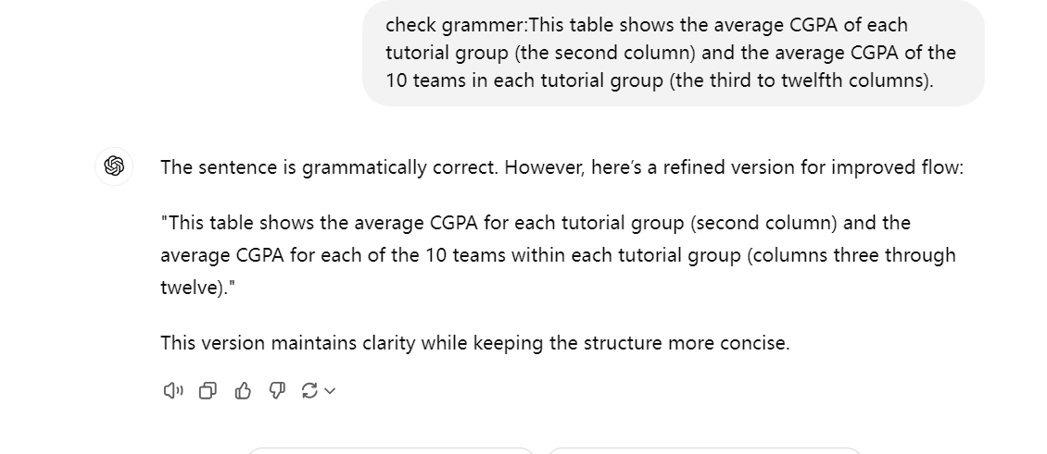
Impact on  submission | grammar checks in the written part

